# WDFW Refugia Analyses and Exploration

Aji John

Christopher Randels

Josh Lawler

School of Environmental and Forest Resources

University of Washington

# Revision history

|  |  |  |
| --- | --- | --- |
| By | Date | Comments |
| Aji John | 07/20/2023 | 1. Removed TNC permeability layer and added Mean topographic complexity layer to Forest and Sage brush steppe refugia. |
|  |  |  |

# Background

Impacts from climate change have already affected a wide range of species and habitats in Washington. These impacts are expected to continue and intensify in the coming years with significant implications for species management and conservation. The conservation of climate-change refugia—locations where species are more likely to persist despite broader, regional climatic changes—is one tool for managing species in a changing climate. This document describes data layers and analyses compiled and performed at the request of the Washington Department of Fish and Wildlife to explore potential climate refugia relevant to wildlife species in Washington. The document and associated layers provide 1) 38 data layers that can potentially serve as indicators of potential climate refugia, 2) an analysis of the degree to which individual refugia layers provide similar or different information, 3) integrated individual data layers identifying refugia for aquatic, forest, and sagebrush steppe environments, 4) analyses of the degree to which aquatic, forest, and sagebrush steppe refugia are protected and the relative intactness of those areas compared to the rest of the landscape, 5) a prototype tool for developing user-defined refugia for individual species or ecosystems, 6) a brief discussion of the potential use of mapped refugia for development and infrastructure planning.

##### 

##### **1. Individual data layers for identifying climate refugia showing locations with high to low refugia potential.**

We selected 38 data layers for identifying climate refugia in Washington (Table 1, 2). These layers represent several different aspects of climatic refugia including potential components of drought refugia, fire refugia, cold water refugia, and topographic refugia. The layers also included more general measures of landscape connectivity and ecological integrity. The layers have a range of spatial resolutions and data types and many cover different spatial extents. All layers can be downloaded from: <https://github.com/ajijohn/Refugia>. Data layers used in the aquatic, forest, and sagebrush steppe refugia presented here are provided in both their raw formats as well as summarized by 12-digit HUCs.

Table 1. Data layers for identifying climatic refugia

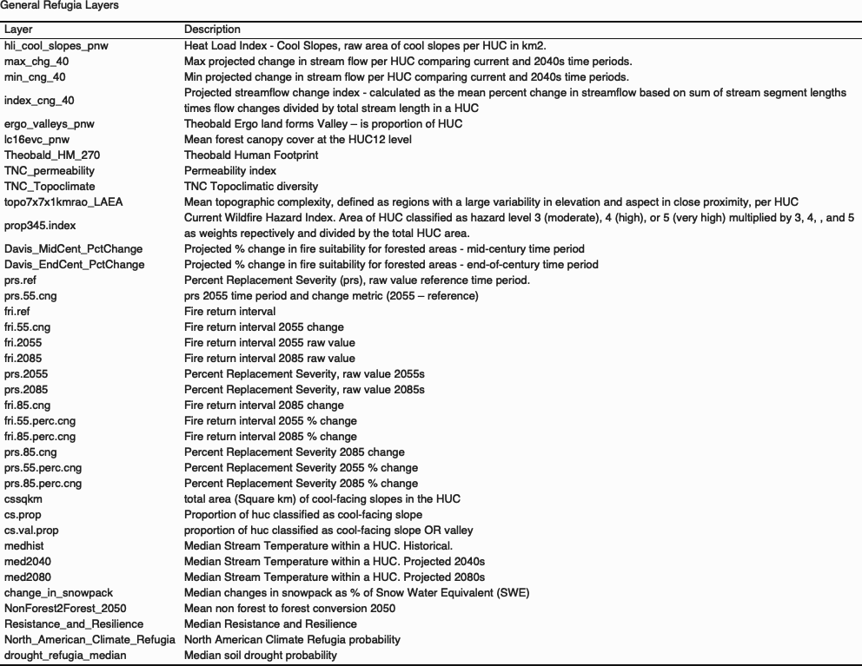

Table 2. Summary statistics for data layers for identifying climate refugia.

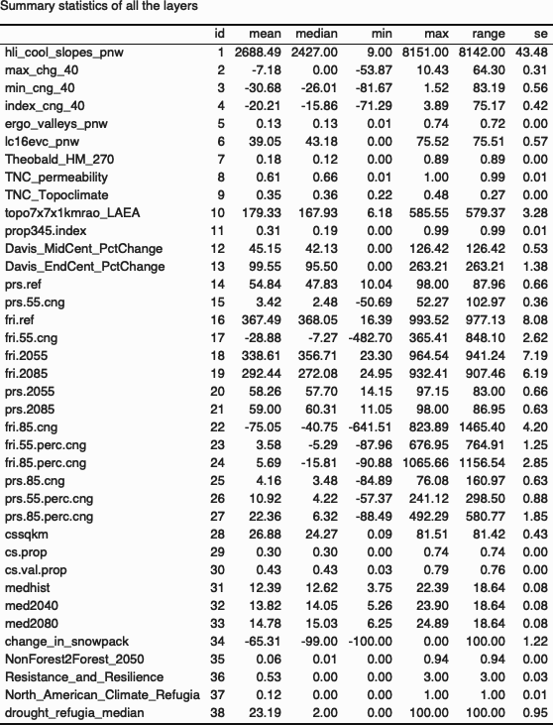

##### 

##### **2. Analysis of the relative distribution of refugia potential based on different input data layers (i.e., which types of locations have high value for different data inputs, are they highly correlated? How do they differ? Which are duplicates versus complementary?)**

We explored the relationships between the different potential refugia layers using Pearson’s correlation coefficients (Figure 1). Many of the variables are highly correlated with others. Most of these higher correlations are among variables that clearly describe a similar element or phenomenon—e.g., different aspects of fire regimes, multiple projections of changes in stream temperature, or different topographic measures.

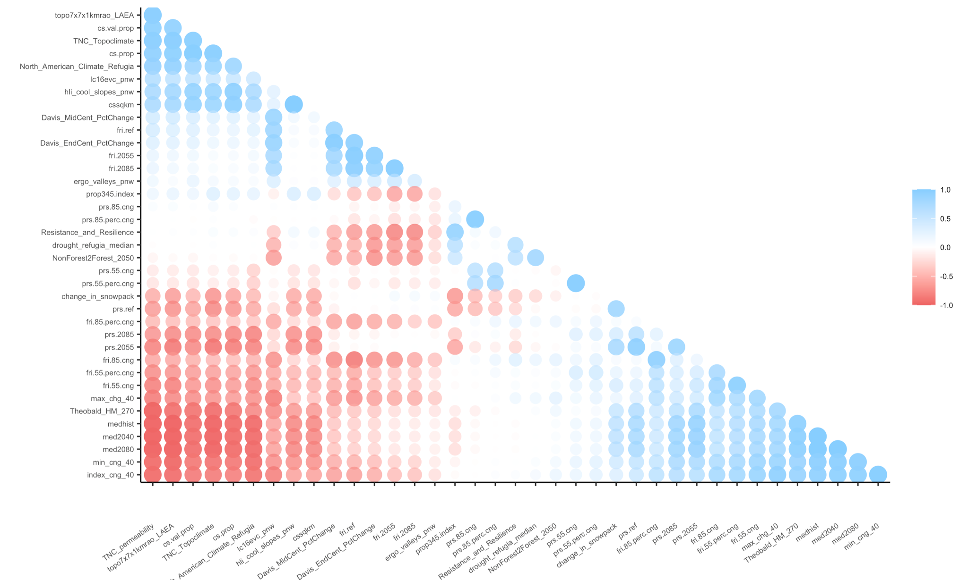

Figure 1. Correlations between all pairs of 38 climate refugia variables**3. Integrated refugia data layer(s) showing locations with high priority across multiple refugia metrics and approaches.**

We explored multiple approaches for combining data layers to identify refugia. As discussed in section 6 (below), we settled on using a discrete threshold approach in which we selected a threshold value for each variable and then identified all of the HUCs on the landscape above or below the selected thresholds for all variables. This approach produced a discrete set of HUCs containing potential climate refugia.

We identified potential aquatic, forested, and sagebrush steppe refugia. Although we identified potential aquatic refugia throughout the state, forest refugia were limited to HUCs with at least 40% forest cover and sagebrush steppe refugia were limited largely to the arid eastern portion of the state and specifically to HUCs in eastern Washington with less than 10% tree cover.

For each of the three refugia types, we selected a set of variables likely to define environmental conditions that would be conducive to the persistence of current ecosystems and ecosystem functions in the face of climate change and projected climate impacts. There was some, although relatively minimal, overlap in the three sets of variables. Using the threshold approach limits the number of variables one can include in an analysis. The more variables one includes, the more restrictive the set of resulting refugia.

Our selection of thresholds was somewhat arbitrary—based more on the distribution of data than it was on ecological thresholds. Setting more restrictive thresholds (e.g., HUCs with a median projected decrease in snowpack of 5% or less) greatly reduces the number of HUCs with potential refugia. The HUCs with potential refugia presented here are merely one possible outcome given the number of different variables that could be combined and the number of different thresholds that could be set. In section 6, below, we describe a prototype of a tool that we developed that would let users explore potential refugia by selecting their own variables and their own thresholds–visualizing the implications of their decisions in real time.

###### **Aquatic Refugia**

We used the following layers, the density distributions of which are shown in Figure 2, to identify potential aquatic refugia.

1. Historic median stream temperatures (medhist)
2. Median stream temperatures 2040s (med2040)
3. Median stream temperatures 2080s (med2080)
4. Cool Slopes Proportion (cs.prop)
5. Stream flow loss (index_cng_40)
6. Mean forest canopy percentage (lc16evc_pnw)

We used initial criteria of HUCs that met all of the following thresholds: a historical median stream temperature below 10 **°** C, projected median stream temperatures in the 2040s and 2080s to remain below 10 **°** C, at least 40% of the HUC having cool slopes, a mean flow loss of less than 40%, and a HUC having a mean forest canopy cover of at least 40%.

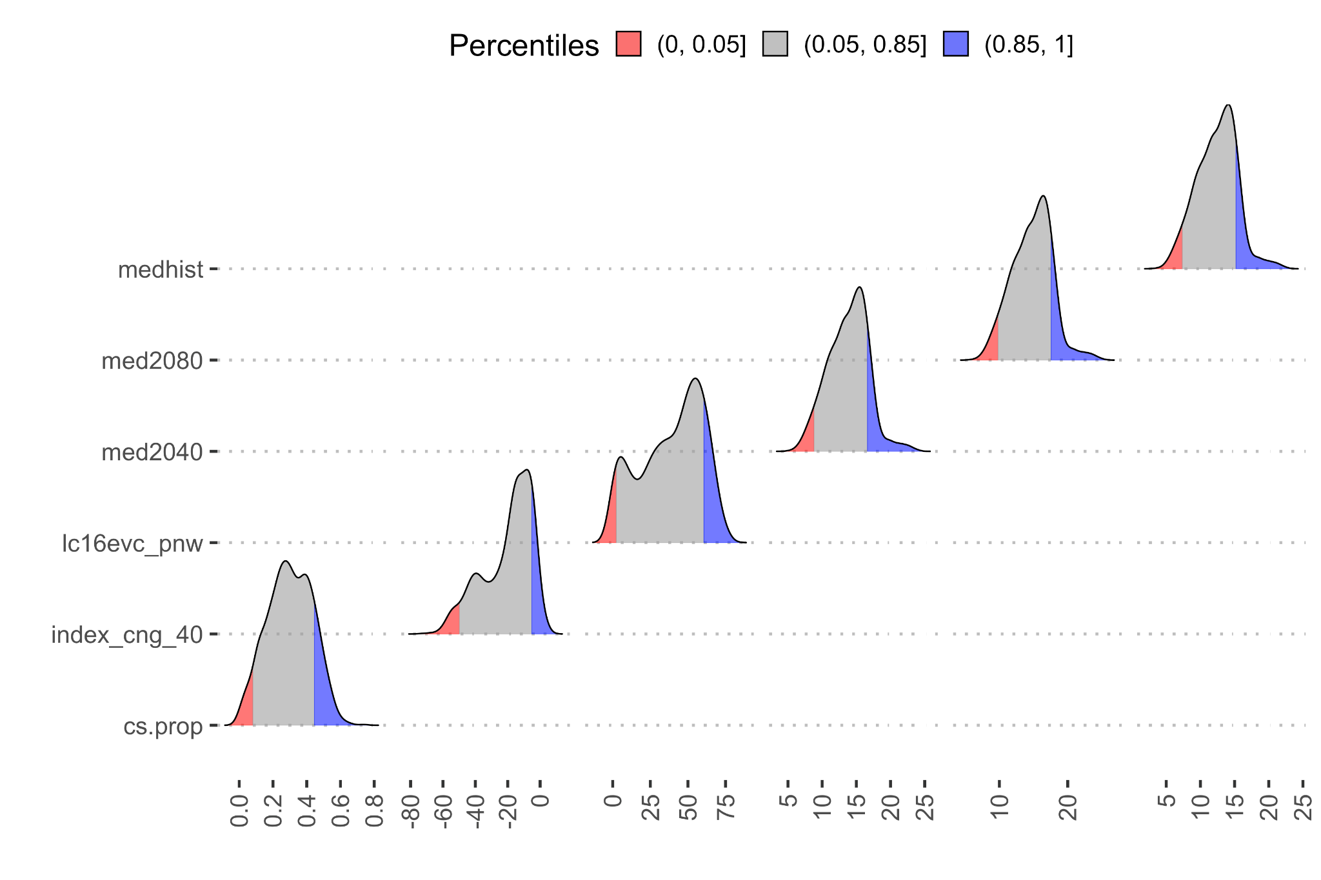

Figure 2. Distributions of the variables used to identify aquatic refugia.

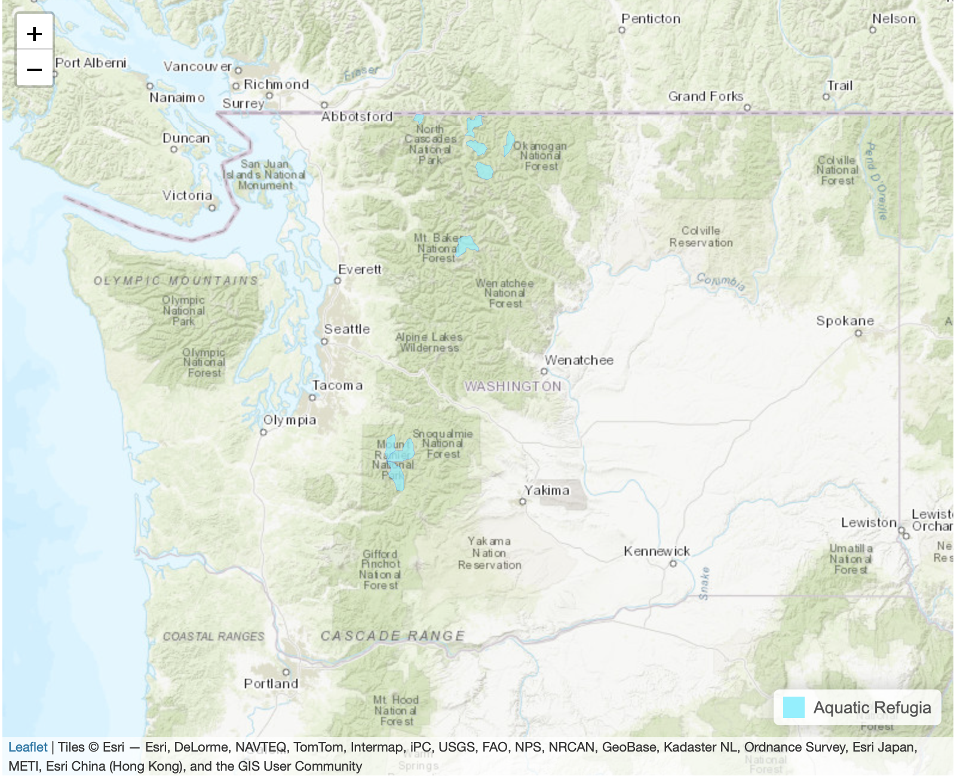

Figure 3. Map of HUCs containing potential aquatic refugia.

###### **Forest Refugia**

We used the following layers, the density distributions of which are shown in Figure 4, to identify potential forest refugia.

1. Mean forest cover per HUC (%) (lc16evc_pnw)
2. Mean topographic complexity (topo7x7x1kmrao_LAEA)
3. Current Fire WHP (prop345_in)
4. Proportion of HUC classified as cool slopes (cs.prop)
5. Drought refugia

To select HUCs that would serve as good forest refugia, we used HUCs with mean forest cover of at least 40%, a mean topographic complexity of 300 or higher, a Current Wildfire Hazard Index of 0.2 or less, at least 40% of the HUC in cool slopes, and mean projected soil drought probability less than 30%.

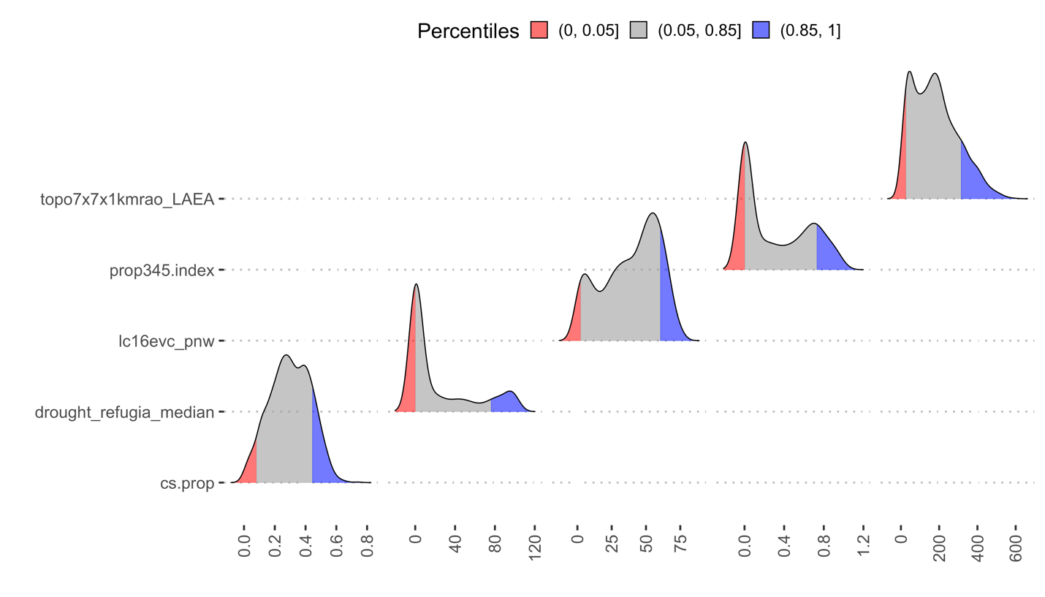

Figure 4. Distributions of the variables used to identify forest refugia.

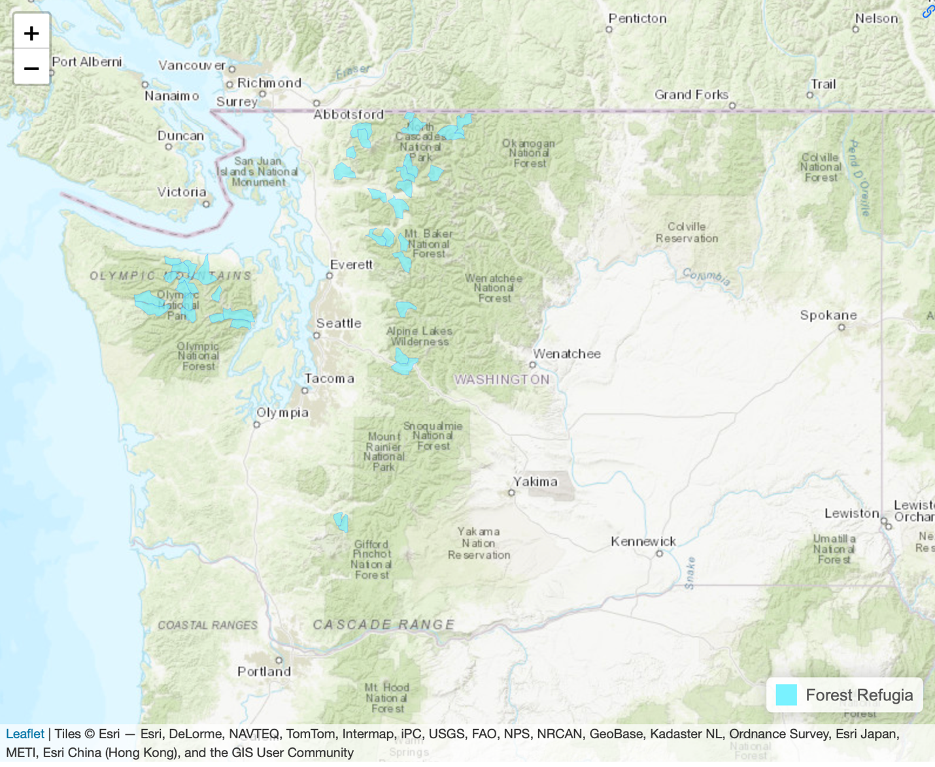

Fig 5: Map of HUCs containing potential forest refugia.

###### **Sagebrush Steppe Refugia**

We used the following layers, the density distributions of which are shown in Figure 6, to identify potential sagebrush steppe refugia.

###### Mean topographic complexity (topo7x7x1kmrao_LAEA)

###### Current Fire WHP (prop345_in)

###### NonForest-2-Forest Conversion 2050 (NonForest2Forest_2050)

###### We set thresholds as mean topographic complexity of 50 or higher, Current Wildfire Hazard Index of 0.2 or lower, and mean probabilities of non-forest to forest conversion of 0 or less.

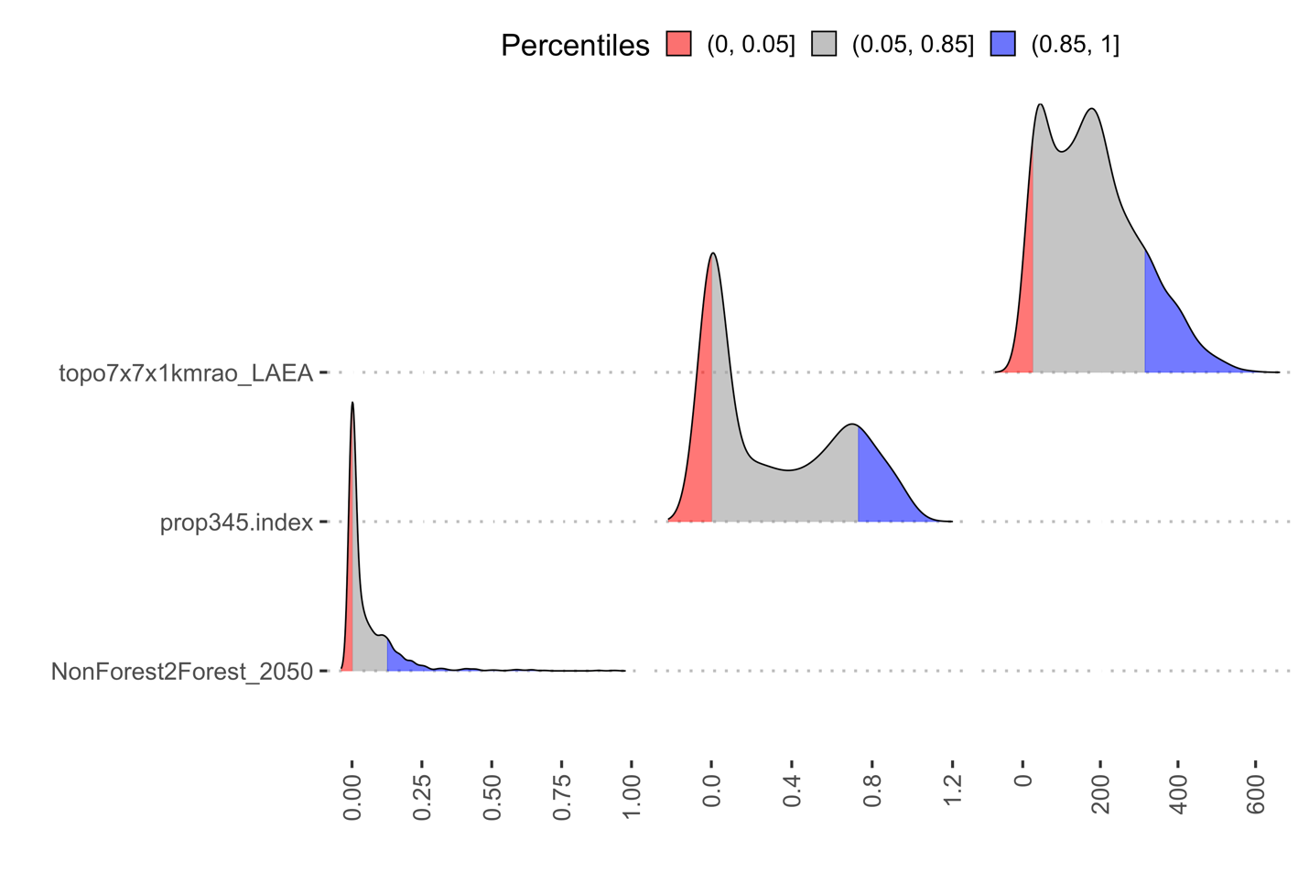

Figure 6. Distributions of the variables used to identify sagebrush steppe refugia.

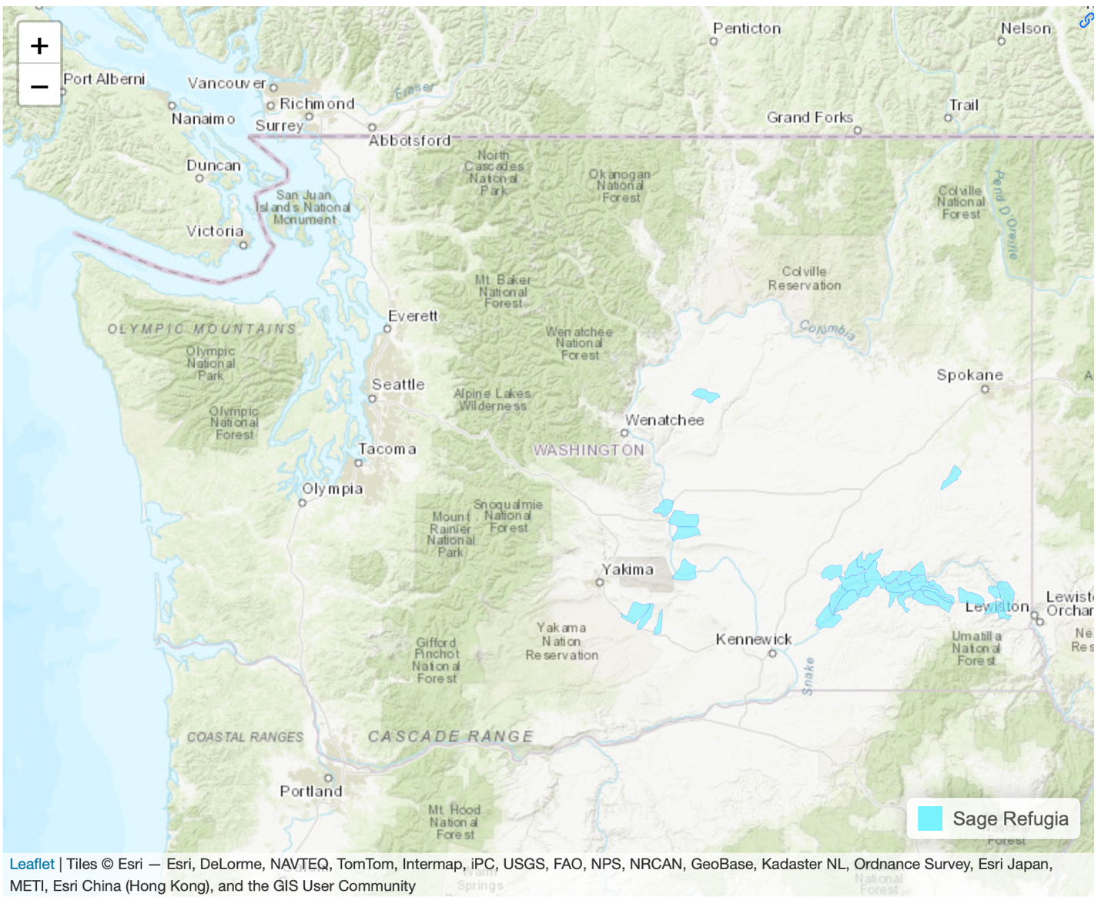

Figure 7. Map of HUCs containing potential sagebrush steppe refugia.

##### 

##### **4. Analyses of identified refugia by protected areas status and landscape integrity. How well protected are identified refugia and how impacted or intact are HUCs containing refugia?**

We explored the degree to which the HUCs identified as containing aquatic, forest, and sagebrush steppe refugia are already protected. To do so, we used data from PAD USA (USGS 2022) to identify protected areas. We used protected areas with GAP 1 & 2 status. To assess whether the HUCs identified as refugia were protected, we overlaid the HUCs on the PAD USA data and identified HUCs as protected using three separate thresholds (25%, 50% and 75% of the HUC in protected land). We then tallied the number of HUCs identified as refugia that were considered protected at each protection threshold level.

At 25%, given the criteria above for the refugia's, there are 363 HUCs that are in protected (public, state or conservancy) in WA. 8 HUCs that are in Aquatic refugia are protected, 0 HUCs that are in Sage refugia are protected, and 27 HUCs that are in Forest refugia are protected. Total HUCs that are protected are 9% of identified refugia HUCs.

At 50%, given the criteria above for the refugia's, there are 271 HUCs that are in protected (public, state or conservancy) in WA. 8 HUCs that are in Aquatic refugia are protected, 0 HUCs that are in Sage refugia are protected, and 24 HUCs that are in Forest refugia are protected. Total HUCs that are protected are 11% of identified refugia HUCs.

At 75%, given the criteria above for the refugia's, there are 187 HUCs that are in protected (public, state or conservancy) in WA. 8 HUCs that are in Aquatic refugia are protected, 0 HUCs that are in Sage refugia are protected, and 18 HUCs that are in Forest refugia are protected. Total HUCs that are protected are 13% of the total protected HUCs.

And, for analyzing landscape integrity, we achieved it by calculating average Theobald value per HUC (Theobald 2013) and comparing refugia hucs to non-refugia hucs based on average Theobald value (Figure 8). We carried this out for all three general refugia types.

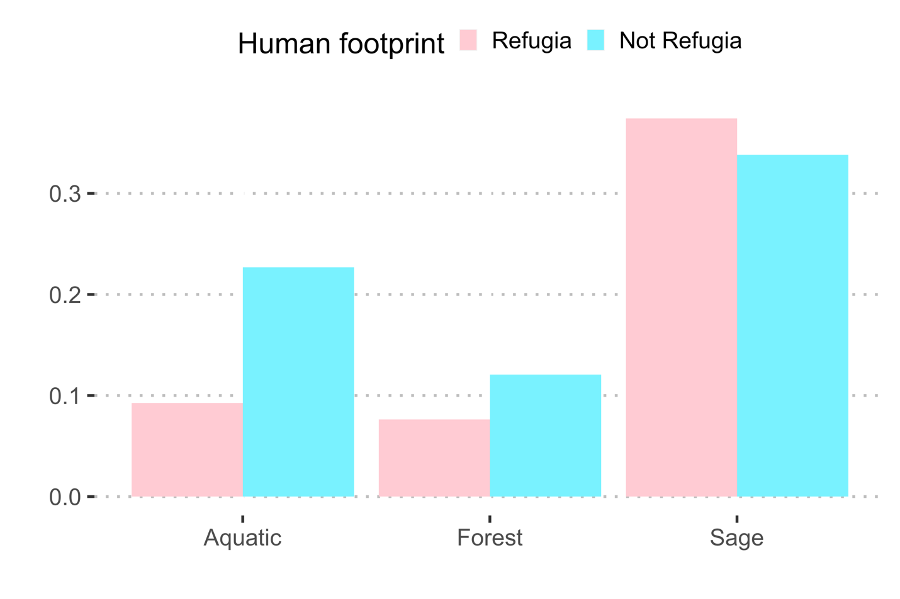

Figure 8. Average human footprint (Theobald 2013) for HUCs with and without refugia across the three landscape settings.

##### 

##### **5. Analysis of the number and types of species that could be potentially served by different refugia locations by overlaying locations with high refugia potential over current range distributions of priority species and habitats (either PHS or SGCN).**

We explored the degree to which the HUCs we identified as containing potential aquatic, forest, and sagebrush steppe refugia overlapped the potential distributions of 83 Washington wildlife species. We used potential habitat as assessed by the Washington Department of Fish and Wildlife (WDFW 2017). We tallied the number of species with at least some refugia within their potential habitat (Figure 9). We also tallied the number of HUCs with refugia of each type within the areas of potential habitat for each species (Table 4).

Below are the number of species served by each refugia.

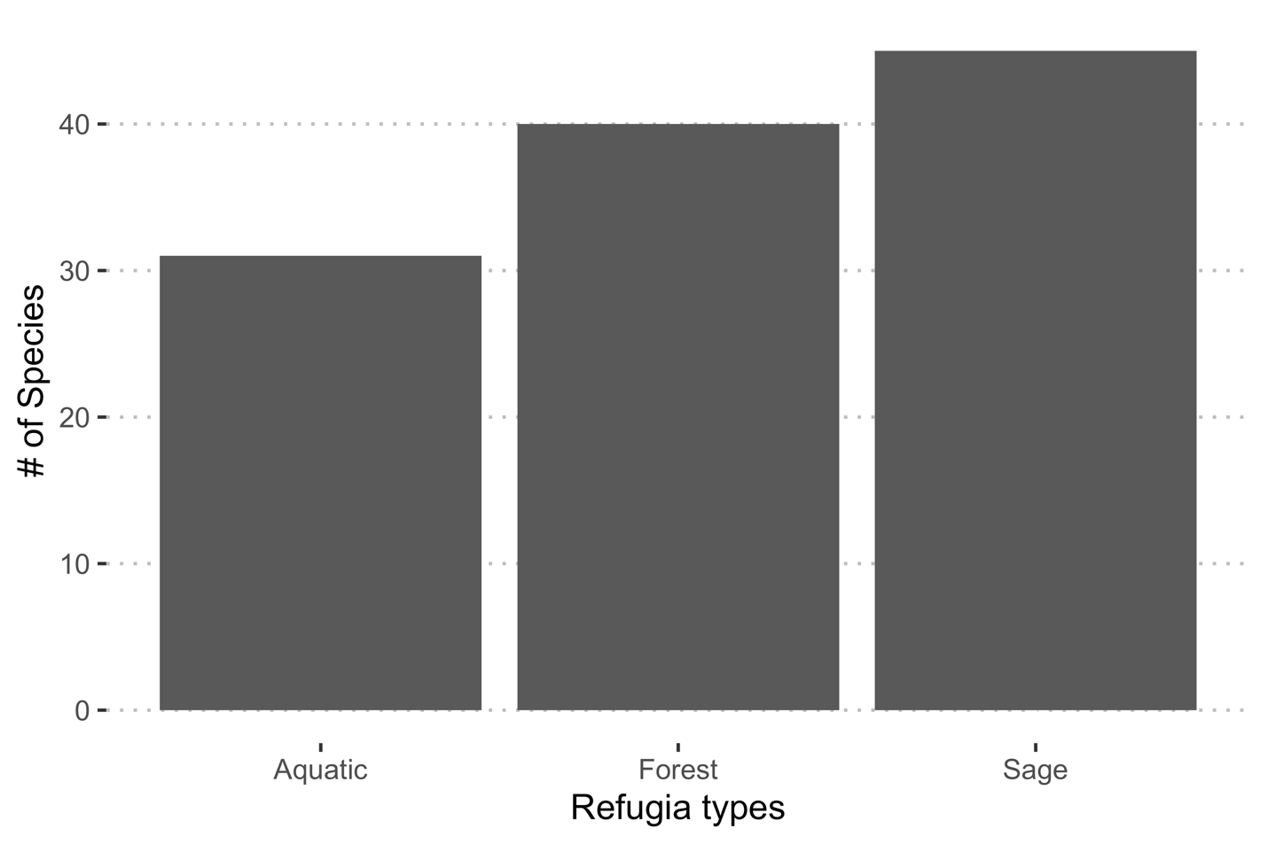

Figure 9. Number of species with potential ranges overlapping at least one HUC containing potential climate refugia.

Table 4. Number of HUCs containing potential refugia within the potential ranges of 78 Washington wildlife species.

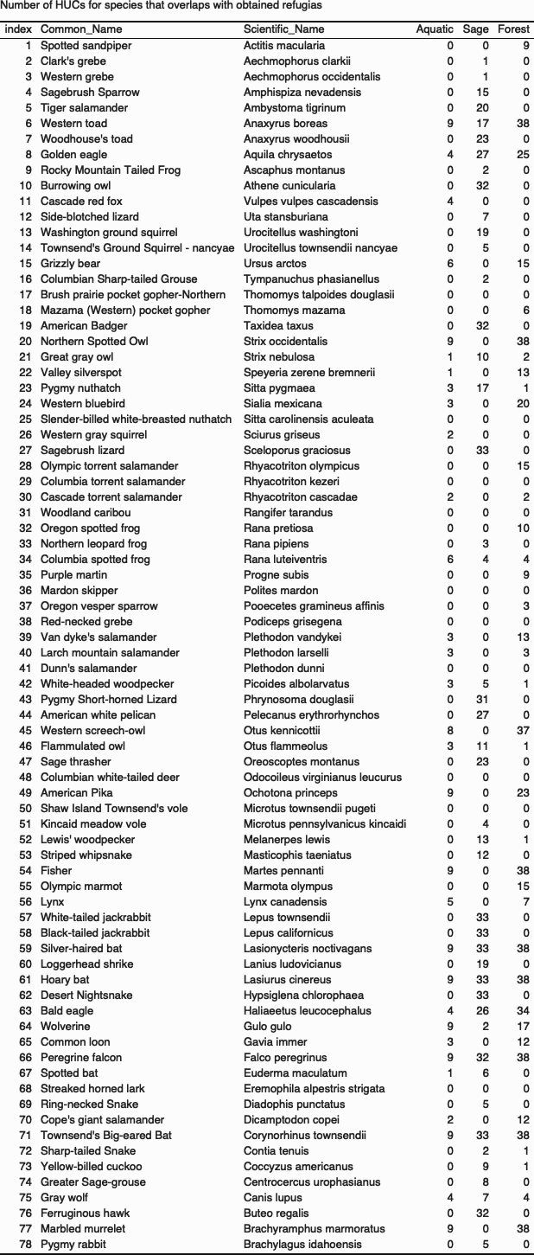

##### **6. Suggestions or exploration of approaches for identifying discrete areas of high refugia potential versus the continuous refugia values.**

Combining multiple data sources to create a single index often requires many decisions about whether to weight factors and how to combine elements. Combining multiple sources of information to identify potential climatic refugia is no different. Ideally, for each element that defines a particular type of refugia, one would set a biologically meaningful threshold (e.g., stream segments that are projected to remain below a specific temperature that corresponds with the upper physiological limit for a given fish species). One could then identify the places on the landscape that are below the thresholds for all of the variables used to identify that type of refugia. In the absence of such biologically meaningful thresholds, one could subjectively select thresholds.

An alternative to setting thresholds for individual variables in the refugia analysis would be to combine continuous variables into one index resulting in a set of continuous values. The user of the index could then select the areas that scored the highest to represent refugia. To be meaningful, this approach would need to thoughtfully weight and scale the variables using knowledge about the species and ecosystems that the refugia were meant to serve. With this approach, the user would still need to determine which values of the combined index would represent refugia that could support target species and systems. Thus, this approach appears to be even more problematic than the threshold-based approach described above.

We used a threshold-based approach for the aquatic, forest, and sagebrush steppe refugia layers presented here. We did so by subjectively selecting thresholds for each variable, based largely on the distribution of the data. However, as mentioned previously, these thresholds for the individual variables should be based on known ecological thresholds for the multiple species and ecosystems that these refugia would support. One approach would be to hold workshops with species and ecosystem experts to select variables and set thresholds and then go off and create refugia layers, have them reviewed by experts, make necessary adjustments, and repeat that cycle. To augment that process–or to allow experts to develop refugia layers on their own–we designed a tool that would allow users or groups of users to select their own variables, set their own thresholds, and generate their own sets of refugia on the fly. We developed a prototype of such a tool that has a set of layers from which users can choose (stored in an on-line database) and sliders for setting thresholds for each of the chosen variables.

The objective of the refugia mapping tool is to support climate-change adaptation efforts by identifying areas that serve as refuge and suitable habitats for individual species, communities, and ecosystems during periods of environmental change or stress (Figure 10). While the tool is still in its prototype stage, it offers several features to facilitate a comprehensive visualization of the inputs involved in creating a holistic refugia mapping.

The tool comprises four main components:

* **Area Selection and Refugia Selection:** Users can choose their area of interest, such as WA, OR, and ID, and specify existing refugia layers (the tool currently has pre-selected refugia for a small number of species).
* **Refugia Layer Inputs:** For identifying their own refugia, users are provided with a list of input layers from which they can choose variables for defining refugia. They can then select and adjust thresholds for those variables and see changes in identified refugia in real-time.
* **Interactive Map with Additional Layers:** The tool includes an interactive map that displays colored HUCs selected as containing refugia. It can also display other layers such as potential habitat for individual species or protected areas.
* **Information and Data Inspection:** Users can access relevant information regarding the selected refugia. Additionally, they can inspect the underlying data used to create the refugia. Density plots are also available, providing a visual representation of the distribution of values.

Figure 10. Screenshot of refugia mapping tool, highlighting four key components (Area Selection and Refugia Type, Interactive Map, Refugia Layer Inputs, and Information and Data Inspection).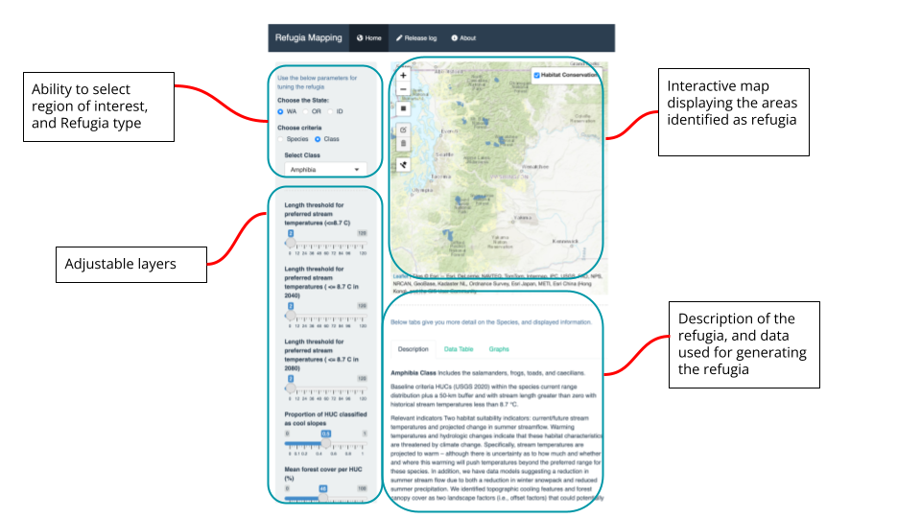

Overall, the refugia mapping tool allows users to select their area of interest, display some existing refugia, select variables for generating their own refugia, adjust thresholds for these variables, generate and visualize refugia, access information on chosen refugia layers, examine the data that contributes to the mapping process, and explore the relationship between refugia and other layers (e.g., potential habitat, protected areas). These features provide a user-friendly and informative interface for understanding and analyzing refugia in the context of climate change adaptation. We look forward to providing an on-line or in-person demonstration of the prototype.

##### **7. Suggestions for guidance to planners on how these types of data could be used to guide development or infrastructure planning [if at all] and if so at what scales?**

##### Climate refugia are areas where species will likely be able to persist or to which species might move as the climate changes. These places are likely to remain cooler, wetter, or drier, than the surrounding landscape. When planning for infrastructure or development, one could use data on refugia locations in at least two ways. First, these are areas where one might try to minimize development and new infrastructure. As they are likely to be important places for plants and animals into the future. Second, one could use the locations of refugia to help guide the placement of wildlife crossings on major roads. Areas around refugia might experience more climate-driven animal movements than other parts of the landscape as individuals move to find climatically suitable areas. To identify locations for wildlife crossings, one would want to use refugia as destinations in a separate connectivity analysis.

##### 

##### The resolution of the refugia produced in this study might be more conducive to planning for road crossings than for planning for new development or infrastructure. We used HUCs as the spatial unit in our analyses to account for the range in the resolution of the data across variables. As such, our results indicate HUCs in which refugia are likely to exist. Although they could be used to steer development away from entire watersheds, they are less useful for guiding development at finer scales (i.e., within HUCs). Refugia identified with finer resolution data could be used to plan for development or infrastructure at finer scales.

##### 

##### 

##### Appendix

##### GitHub Repository for layers and ancillary code

The data and the code are archived in <https://github.com/ajijohn/Refugia.git>.

##### Density distribution of all the layers

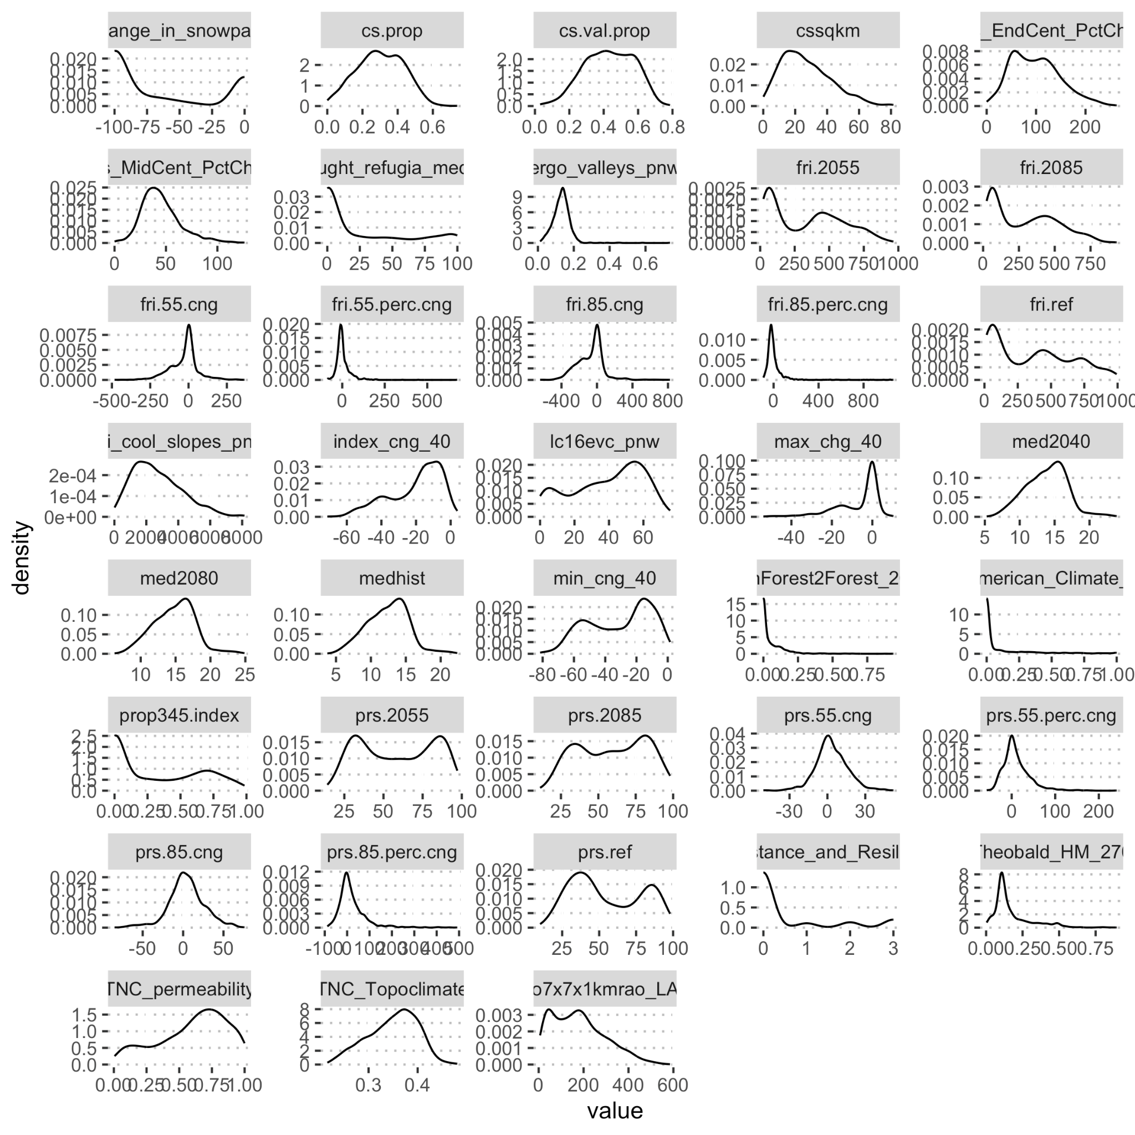

##### Fig. B Density distribution of all the layers

##### References

Cartwright JM ed. 2020. A guidebook to spatial datasets for conservation planning under climate change in the Pacific Northwest. U.S. Geological Survey. Available from <https://doi.org/10.5066/P92L1H7O>.

Theobald, D.M. A general model to quantify ecological integrity for landscape assessments and US application. *Landscape Ecol* **28**, 1859–1874 (2013). <https://doi-org.offcampus.lib.washington.edu/10.1007/s10980-013-9941-6>

U.S. Geological Survey (USGS) Gap Analysis Project (GAP), 2022, Protected Areas Database of the United States (PAD-US) 3.0: U.S. Geological Survey data release,

<https://doi.org/10.5066/P9Q9LQ4B>.

Washington Department of Fish and Wildlife (WDFW). 2017. Species Ranges 2015 – State Wildlife Action Plan. Washington Department of Fish and Wildlife, Olympia, Washington, USA. Available at

<https://data-wdfw.opendata.arcgis.com/datasets/species-ranges-2015-state-wildlife-action-plan>. Accessed June 10, 2017.